

Students Name:………………………………………

SPECIALIST MATHEMATICS

TRIAL EXAMINATION 1

2015

Reading Time: 15 minutes
Writing time: 1 hour

Instructions to students
This exam consists of 9 questions.
All questions should be answered.
There is a total of 40 marks available.
The marks allocated to each of the questions are indicated throughout.
Students may not bring any notes or calculators into the exam.
Where more than one mark is allocated to a question, appropriate working must be shown.
Where an exact answer is required to a question, a decimal approximation will not be accepted.
Unless otherwise indicated, diagrams in this exam are not drawn to scale.
The acceleration due to gravity should be taken to have magnitude 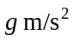where 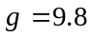
Formula sheets can be found on pages 11-13 of this exam.

This paper has been prepared independently of the Victorian Curriculum and Assessment Authority to provide additional exam preparation for students. Although references have been reproduced with permission of the Victorian Curriculum and Assessment Authority the publication is in no way connected with or endorsed by the Victorian Curriculum and Assessment Authority.

© THE HEFFERNAN GROUP 2015
This Trial Exam is licensed on a non transferable basis to the purchasing school. It may be copied by the school which has purchased it. This license does not permit distribution or copying of this Trial Exam by any other party.
Question 1 (3 marks)

Evaluate 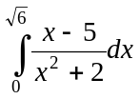

Question 2 (5 marks)

OAB is a triangle where C is the midpoint of 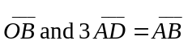.
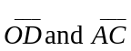 intersect at point M.
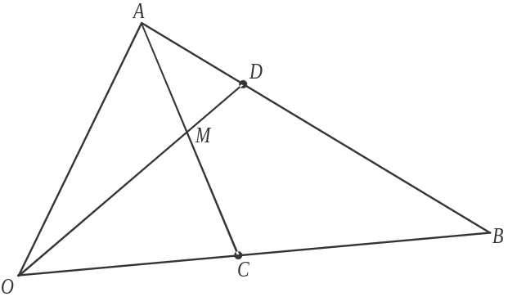

Let 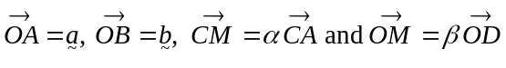.

- Express 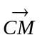 in terms of

  - 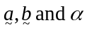. 1 mark

  - 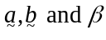 2 marks

- Hence find the values of 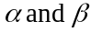. 2 marks

Question 3 (3 marks)

Let 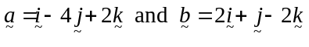.
Resolve into two vector resolutes, one parallel to and the other perpendicular to .

Question 4 (4 marks)

Let 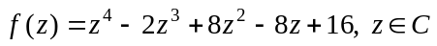. Given that is a solution of 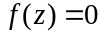, find all the other solutions in Cartesian form.

Question 5 (5 marks)

A box of mass 2kg rests on a rough horizontal floor. It is given a one-off push which causes it to travel across the floor with an initial velocity of 10m/s. The frictional force F shown in the diagram below, exerted by the floor on the box, causes the box to come to rest 4 seconds later.



- Find the acceleration of the box across the floor. 2 marks

- How far does the box travel before coming to rest? 1 mark

- The coefficient of friction between the box and the floor equals 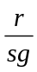, where r and s are positive integers and is a fraction expressed in simplest form.
Find the values of r and s. 2 marks

Question 6 (4 marks)

Find the gradient of the tangent to the curve defined by 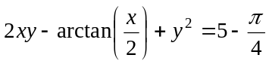 at the
point 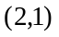.

Question 7 (4 marks)

Calculate the area of the region enclosed by the graphs of 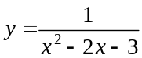, and the x and y axes.

Question 8 (5 marks)

A particle moves in a straight line with acceleration a m/s², velocity v m/s and position x m, relative to a fixed point on the line. The relationship between the position and the velocity of the particle at time t seconds, 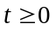, is given by 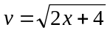. The particle is initially at the fixed point.

- Show that the acceleration of the particle is constant. 2 marks

- Find the value of x when . 3 marks

Question 9 (7 marks)

Consider the function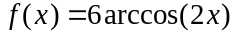.

- Write down the maximal domain and range of f. 2 marks

- Sketch the graph of 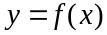 on the set of axes below. Label any endpoints and axes intercepts with their coordinates. 2 marks

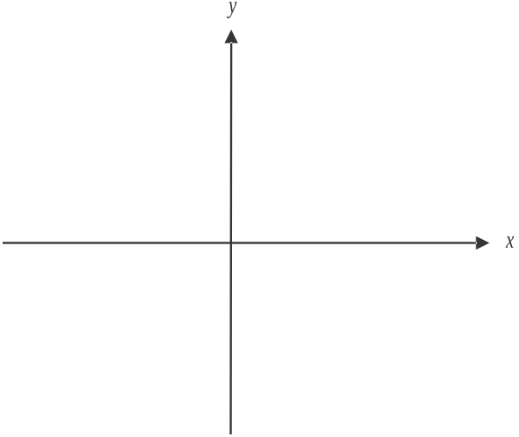

The region enclosed by the x and y axes and the graph of is rotated about the y-axis.

- Find the volume of the resulting solid of revolution. 3 marks

Specialist Mathematics Formulas

Mensuration
area of a trapezium: 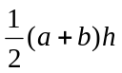
curved surface area of a cylinder: 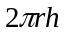
volume of a cylinder: 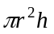
volume of a cone: 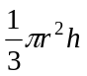
volume of a pyramid: 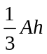
volume of a sphere: 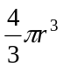
area of a triangle: 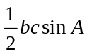
sine rule: 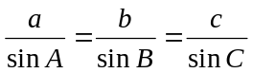
cosine rule: 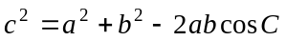

Coordinate geometry
ellipse: 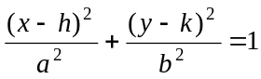 hyperbola: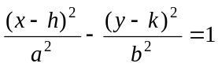

Circular (trigonometric) functions
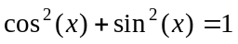
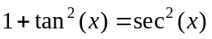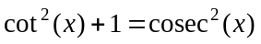
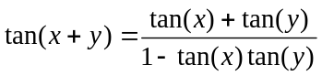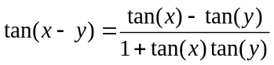
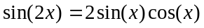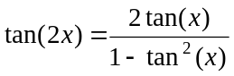
function | 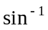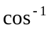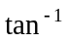
domain  range | 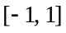  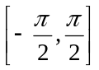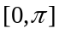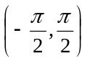

Algebra (Complex numbers)
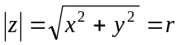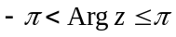
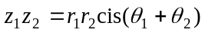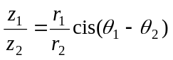
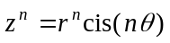 (de Moivre’s theorem)
Mathematics Formula Sheets reproduced by permission; © VCAA 2014. The VCAA does not endorse or make any warranties regarding this study resource. Current and past VCAA VCE® exams and related content can be accessed directly at www.vcaa.vic.edu.au
Calculus

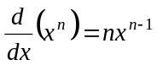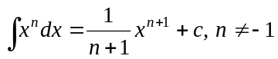
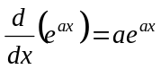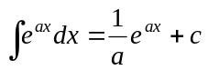
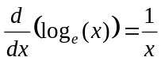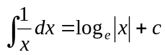
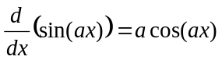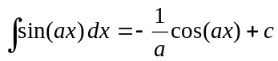
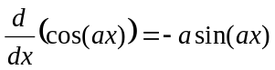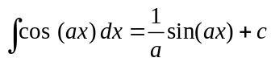
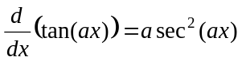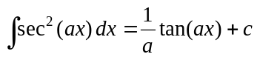
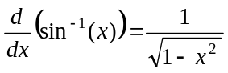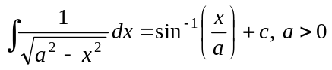
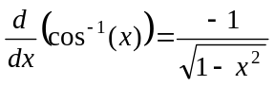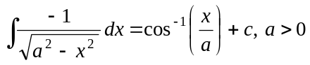
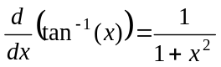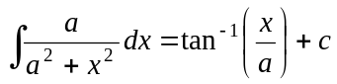

product rule: 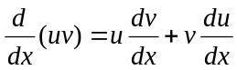
quotient rule: 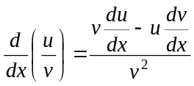
chain rule: 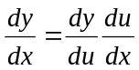
Euler’s method: 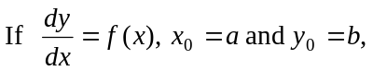
acceleration: 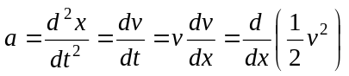
constant (uniform) acceleration: 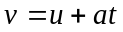 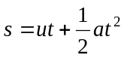 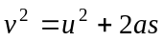 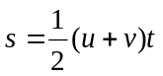

Vectors in two and three dimensions

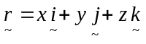
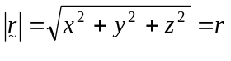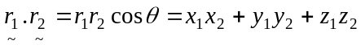
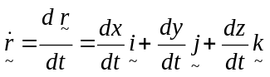

Mechanics

momentum: 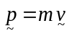
equation of motion: 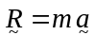
friction: 